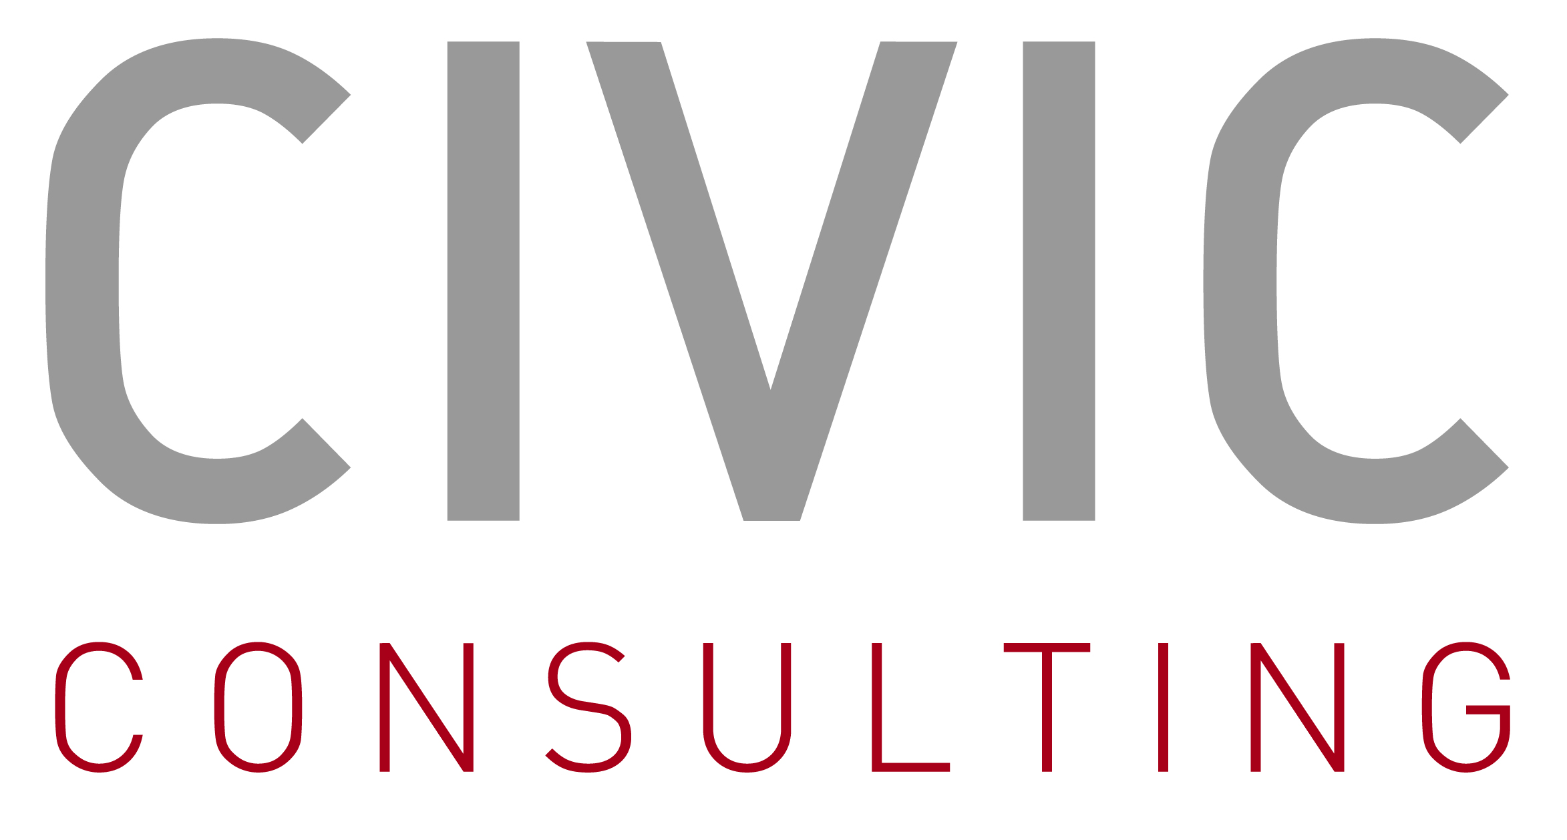

Evaluation of the EDC Network
*
survey of institutional users of the european documentation centres

Please return filled questionnaire by email to edc@civic-consulting.de no later than
16 April 2007
(please return in Word format and do not convert to a pdf document)

DG Communication of the European Commission has launched an external evaluation of the network of European Documentation Centres. You have been identified by the EDC at your university or institution to be one of the institutional users of the EDC, meaning that either you yourself, your staff and/or your students are potentially involved in research or studies on European issues. The evaluation will examine the effectiveness of European Documentation Centres and will assess how the network could provide better services to users in the future.

The information you will provide through this questionnaire will be crucial in assessing whether the EDC meets the needs of the users. We therefore greatly appreciate your contribution. The data obtained through this questionnaire will not be used to assess the performance of the individual EDC you use, but will rather provide the user perspective regarding the services of the network as whole.

If you have any further questions, do not hesitate to contact:
Merle Achten (edc@civic-consulting.de) Phone: +49-30-2196-2295 Fax: +49-30-2196-2298
- Please identify yourself:

  - Country:

Please specify

  - Please identify your position:

  - Questionnaire completed by (optional):

Name, position, contact details

- Please estimate how often you, your staff and/or the students that are conducting research on EU integration or other EU relevant issues use the EDC on average? Note: If possible, discuss this question with your staff and/or students.

- Do the documentation services of the EDC meet your needs?

- Please assess the degree to which documents available meet the needs of yourself, your staff and/or your students.

- Please assess the degree to which databases accessible at EDC computers meet the needs of yourself, your staff and/or your students.

- Please assess the degree to which assistance provided by EDC staff meets the needs of yourself, your staff and/or your students.

- Please assess the strengths and weaknesses of the documentation services provided by the EDC.

- If you think that the documentation services meet needs well, what do you consider to be the main strengths of the EDC in this respect?

Please specify

- If you think that the documentation services are insufficient, what do you consider to be the main weaknesses of the EDC in this respect?

Please specify

- Please assess the communication activities of the EDC.

- According to your experience, to which degree is the EDC known to potential users (e.g. colleagues, students)?

- According to your experience, to which degree do the communication and promotion activities organised by the EDC (such as courses, seminars, conferences, competitions, book presentations related to the debate on the EU) reach potential users (e.g. colleagues, students)?

- Please assess the degree to which the activities (such as courses, seminars, conferences, competitions, book presentations related to the debate on the EU) organised by the EDC meet the needs of yourself, your staff and/or your students.

- How important is the EDC for you as an information source for your research on EU integration or other EU relevant issues?

- Does the EDC currently – in your view – contribute to the promotion and development of studies and research work in the field of European integration?

- With the evolving information technologies and needs, how could the EDC remain a valuable tool and offer an added value to you?

Please specify

E.g. faculty members, staff of research institutes dealing with European issues.

